Demonstration of Proposed Features
Project Name: RK Health AI – Smart Healthcare Management System
Team ID:
Date: 16-07-2026
S.No | Proposed Feature | Demonstrated | Screenshot / Evidence | Remarks
1 | Dashboard Overview | YES | 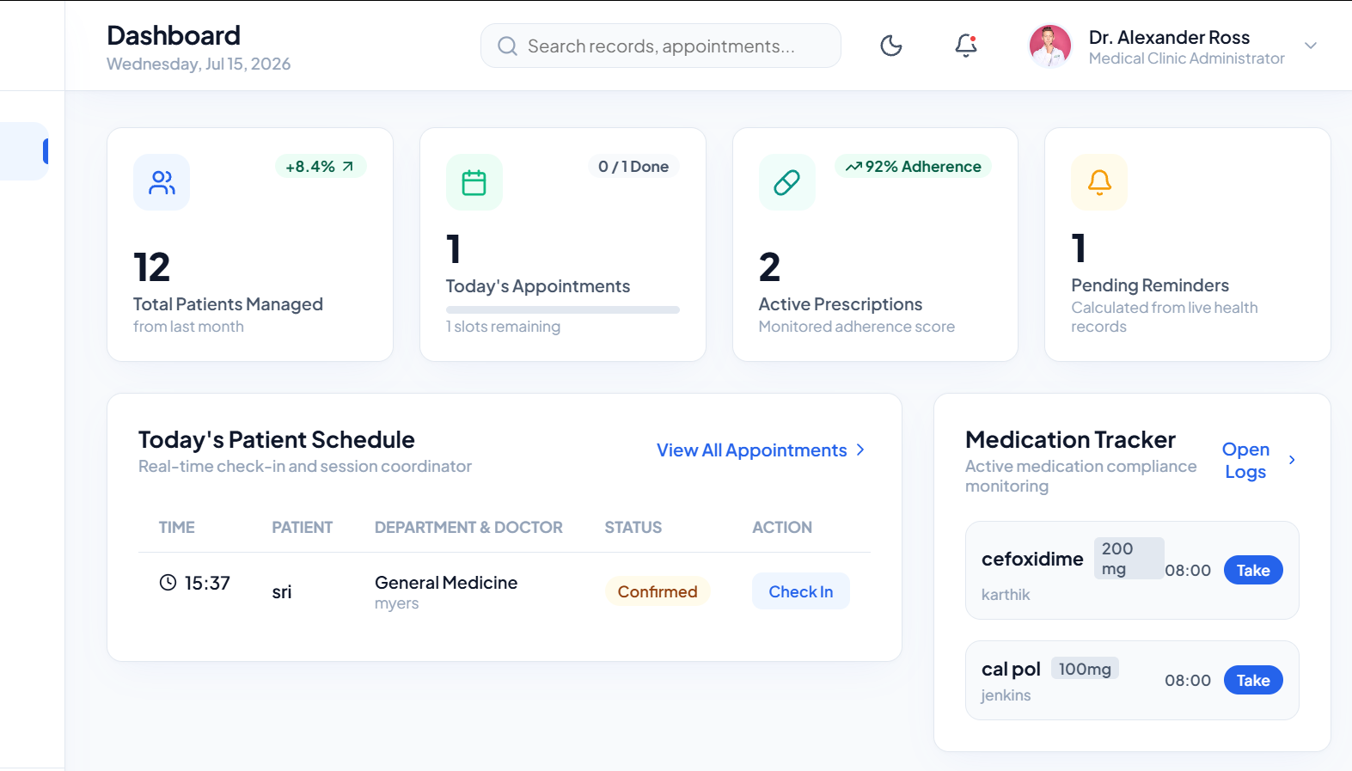 | WORKING
2 | Appointments Directory | YES | 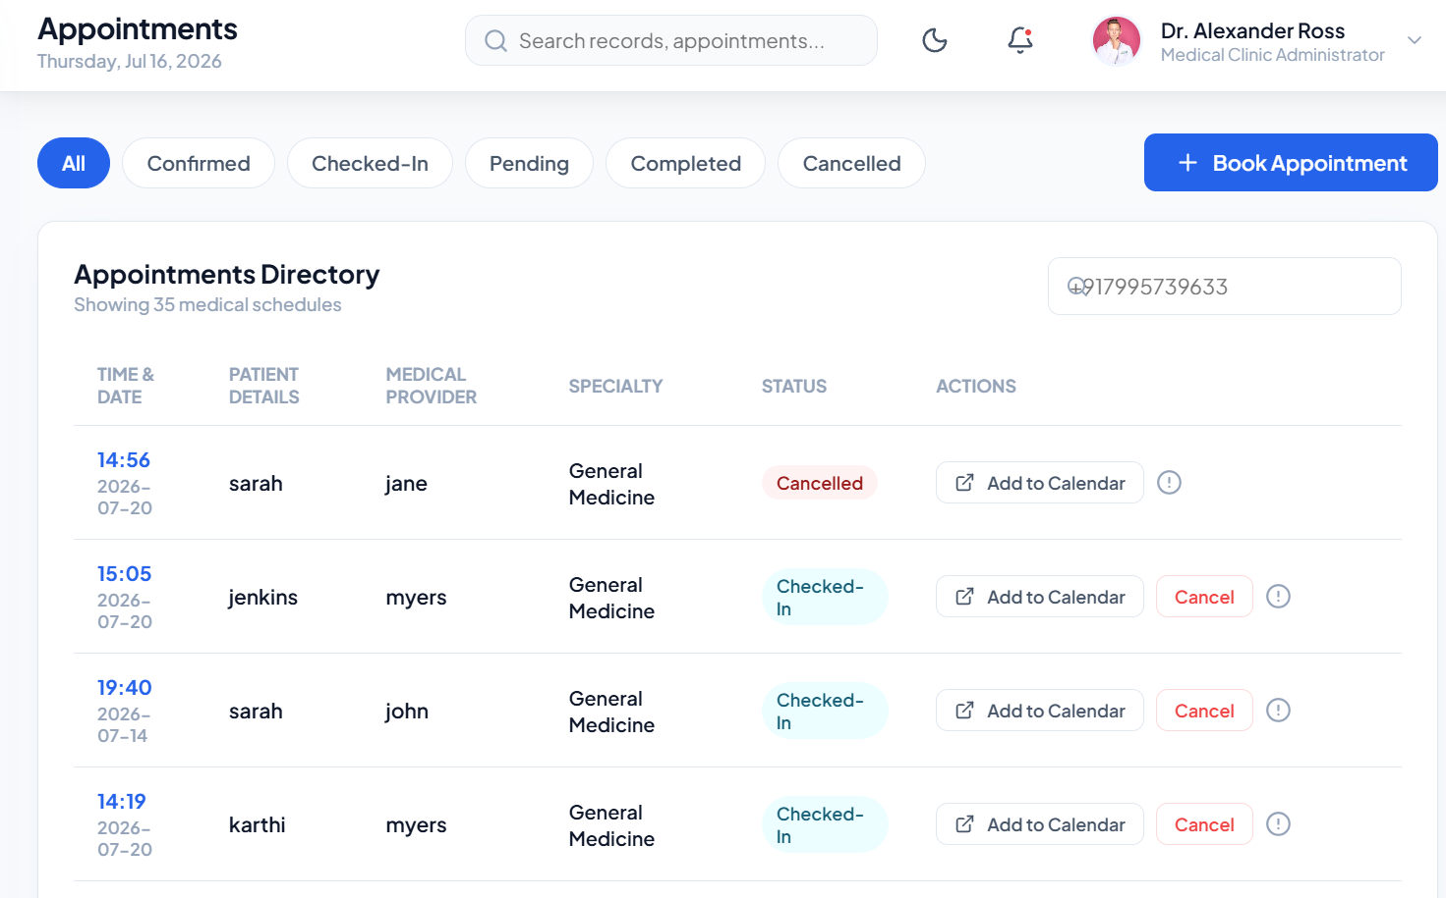 | WORKING
3 | Book Appointment | YES | 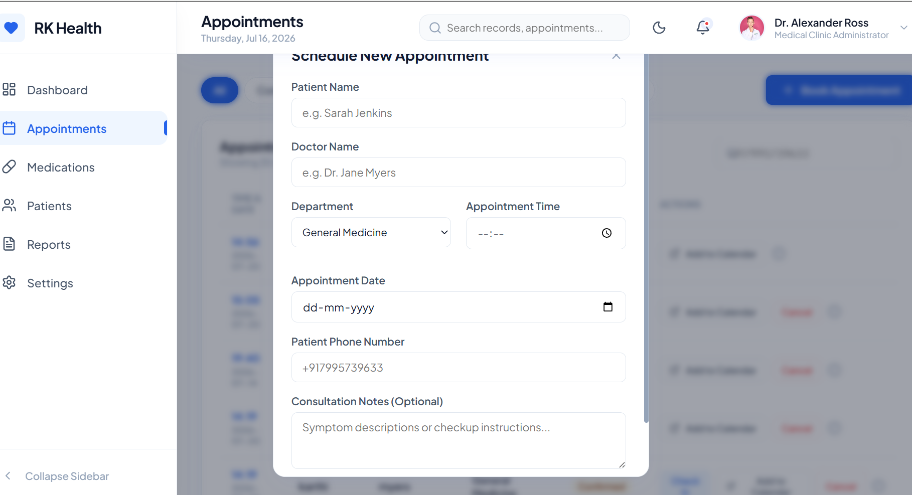 | WORKING
4 | Medication Management | YES | 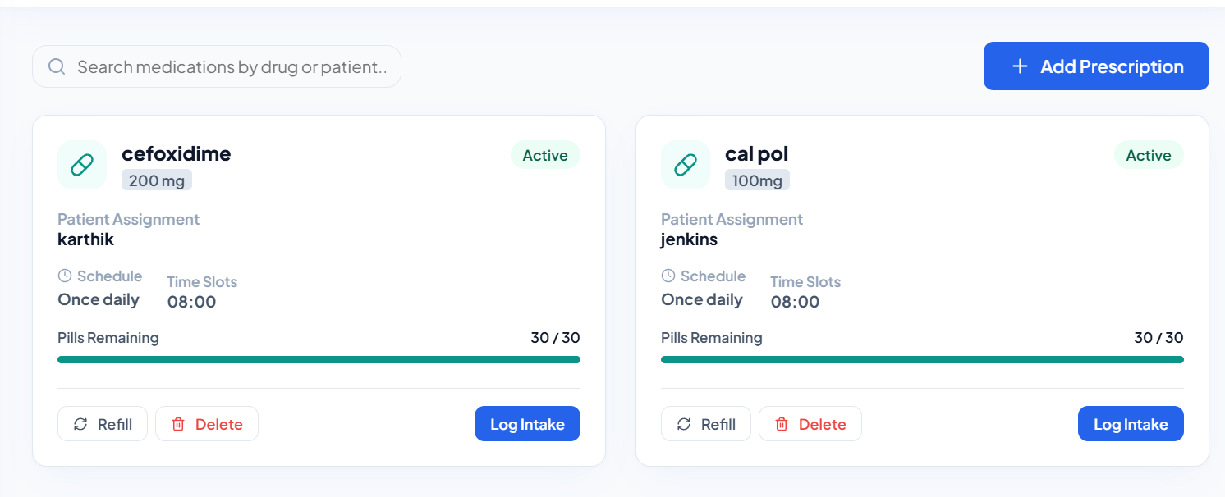 | WORKING
5 | Patient Management | YES | 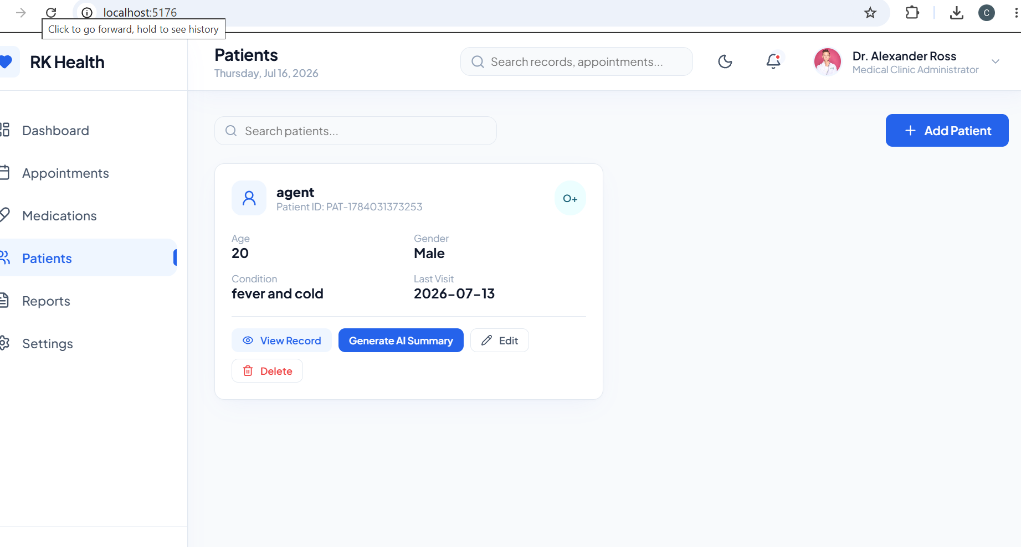 | WORKING
6 | AI Health Summary | YES | 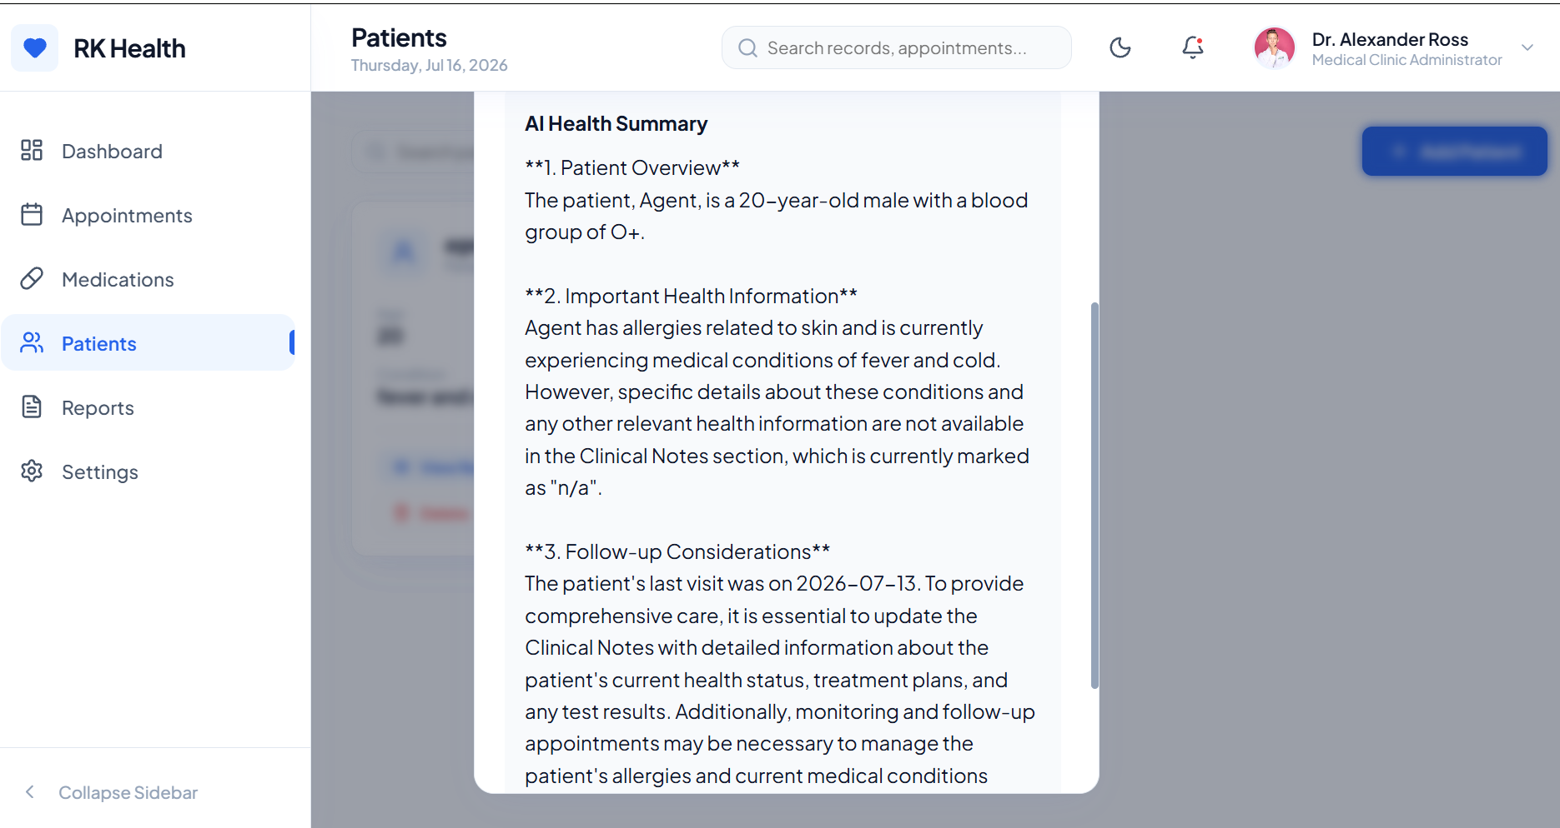 | WORKING

